
Cleansing Cab Ride Data

Teacher Talk Track
Before the lesson be sure to:
- Distribute the Cab Company Data.xlsx file.
Open Designer
Today we are going to be investigating and cleaning data on cab fares from two companies so that the pricing structure of the cab fares can be analyzed.

The Workflow
First open Excel File!

Input Data
Have students import the dataset Cab Company Data.xlsx from their folder by locating it on their computer and dragging it onto the Canvas.
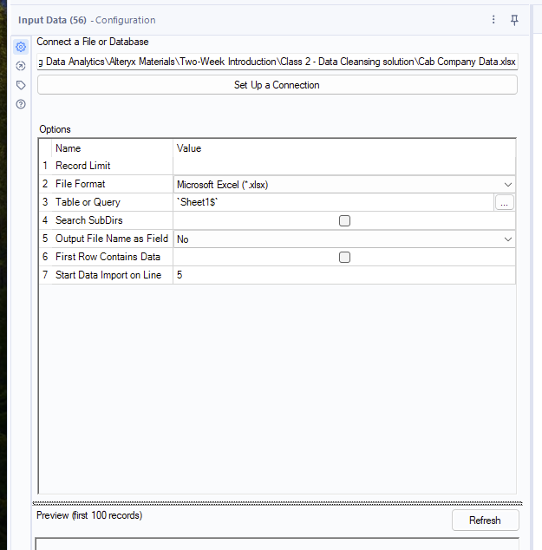
This is another way to connect to a dataset. When you do this, it will automatically configure the Input Data tool for that dataset. Click Run.
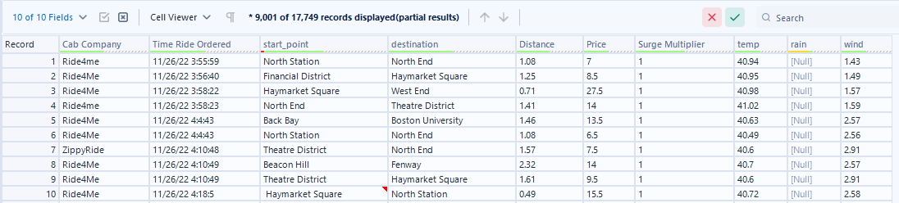
Notice a few things might look different from last class. Take a few minutes to look over the Results window.
- This dataset has more data than can be viewed in the Results window.
- The data quality bar has different colors besides green. Hover over the different columns to see what data quality issues may be present.
Green means good to go. Yellow means there are null values. Gray means there are empty records. Red means there are leading or trailing white spaces or embedded new lines. Alternating gray and white stripes means only partial results are being displayed.
Note: If you are running an old version of Designer you may need to add a Browse tool and re-run the workflow to get the data quality bar to display.
- There are some red flags in the [start_point] Column. You can hover over the record to see what is causing the red flag. We will also investigate this further in the Browse tool.
Attach a Browse tool and re-run the workflow to show all the records and start investigating the data.
The columns [Cab Company] and [Price] have a few null values. The majority of the values in the column [rain] are null.
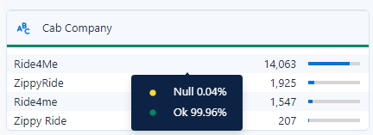
At first glance, it looks like there are four different cab companies, but if you look closer it appears to be just capitalization and spacing issues. There are also some null values present.
The rides occurred in November and December of 2022.
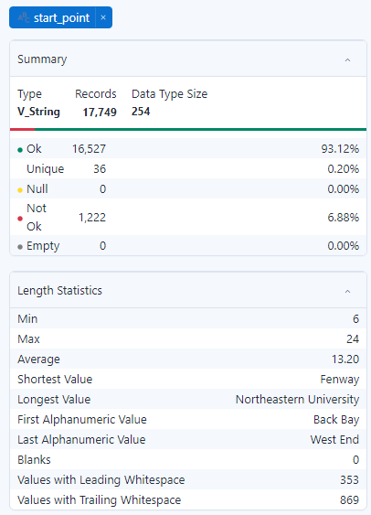
The same 12 locations appear in the [start_point] and [destination] locations.
The surge multiplier values are all multiples of 0.25
There are some Not Ok records in the [start_point] field. Click on [start_point] in the Configuration of the Browse tool. You can see that we have leading and trailing whitespace issues in this column. This is what was causing the red flags in the results window and the Not OK indicator.
All the data types are string, so many should be updated to more appropriate ones.
The header formatting is inconsistent as well.

Questions
Questions students might have about the data:
The weather values repeat frequently. How were they measured? The weather measurements were taken approximately every hour.
What does the [rain] value mean? It is the amount of rain in the last hour.
What are the units on these? [Distance] is in miles, [Price] is in dollars, [Surge Multiplier] is a scalar, [temp] is in Fahrenheit, [rain] is in inches, and [wind] is the highest wind gust in the last hour measured in miles per hour.
What is a surge multiplier? When demand for cab rides is high relative to the supply of drivers, fees are increased. The surge multiplier is what the base fee is multiplied by to get the final price of the trip shown.

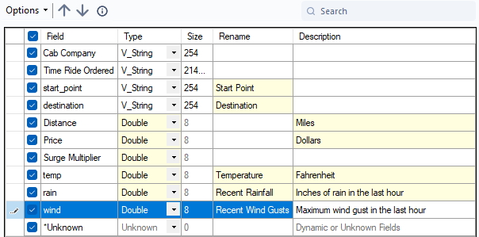
Select Tool
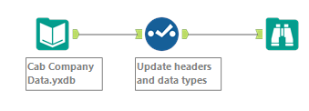
Drag a Select tool onto the Canvas and connect it to the Input Data tool. Give students a minute to configure the tool on their own, then review the configuration as a class.
Sometimes adding units to the header makes sense, but you can also put them in the column description.
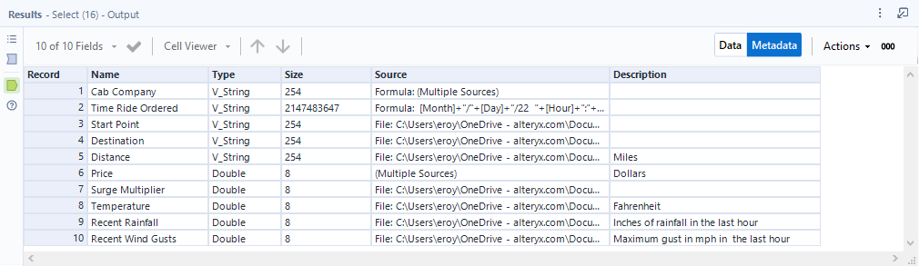
Descriptions will appear in the Metadata tab of the Results window for the remainder of the workflow.
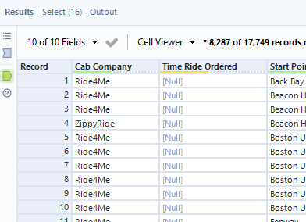
Your students may try to change the [Time Ride Ordered] column to a date time data type. This will not work because those values are not in the format required of a date time data type. As a result, all of the values become null. We will address how to make this change later in the lesson. Leave [Time Ride Ordered] as a String data type for now.
Update the annotation of the Select tool to “Update headers and data types”

New Tools

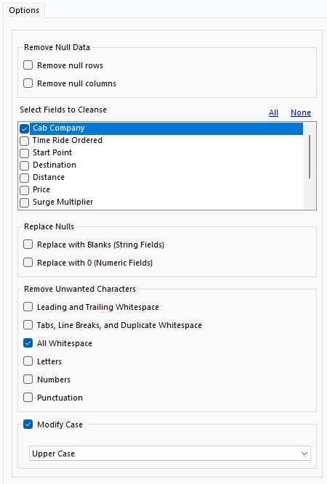
Data Cleansing Tool
The Data Cleansing tool is a great tool for performing many basic data cleansing tasks. It can address unwanted whitespace, remove categories of characters entirely, modify cases, and more.
Drag a Data Cleansing tool to the Canvas and connect it to the Select tool.
Let’s start by addressing the [Cab Company] name issue.
Select [Cab Company]. This column does not have any Nulls to replace or leading or trailing white space, so we can uncheck the Replace Nulls options and Leading and Trailing Whitespace.
We have two issues we need to take care of.
- Cab company Ride4Me has a capitalization issue. To fix this check Modify Case and select Upper Case.
- Some of the cab company records for ZippyRide have a space between the words. To remove it select All Whitespace under Remove Unwanted Characters
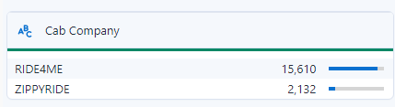
Run the workflow.
When we view the data in the Browse tool, we can see that the [Cab Company] column now only has two companies.
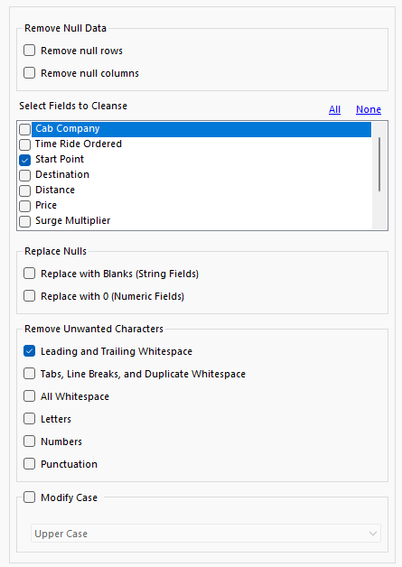
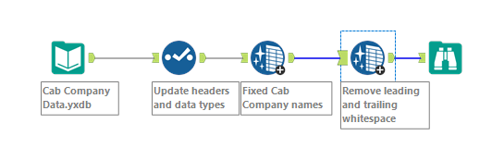
Next, let’s take care of the whitespace issue in the [Start Point] column. Drag another Data Cleansing tool onto the Canvas and connect it to the first Data Cleansing tool.
Select [Start Point]. This column does not have any Nulls to replace so we can uncheck the Replace Nulls options. Only check the Leading and Trailing Whitespace from the Remove Unwanted Characters section.
Note: You might consider it to be good practice to keep all columns selected when only removing leading and trailing whitespace to ensure you did not miss a record having this issue.
Run the workflow. When we view the data in the Browse tool, we can see that the [Start Point] column is now clean and that the leading spaces were removed.
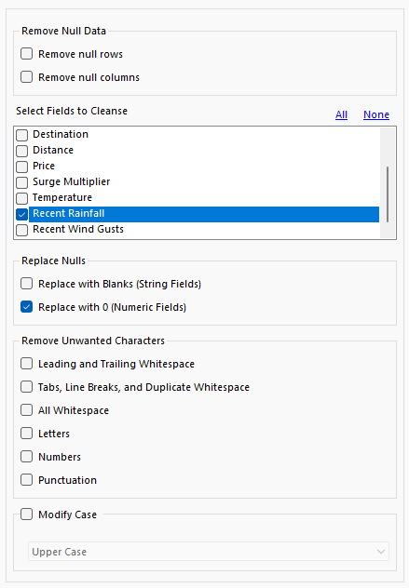
Lastly, let’s take care of the null values in the [Recent Rainfall] column. These nulls don’t imply a lack of information in this case, it’s that there was no rainfall. In this case, replacing those null values with 0 makes sense because that is a more accurate representation of those values.
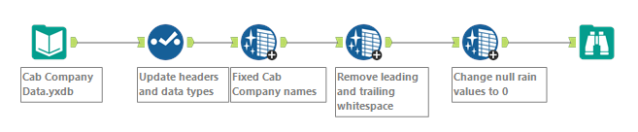
Configure the tool as shown.
Don’t forget documentation. Annotations are sufficient for now, but you could also use comment tools if preferred.

While the dataset is in much better shape, we still have some null values to address. Let’s start by addressing the null values in the [Price] column.
Again, in some instances, having a few null values isn’t a big deal and won’t impact our analyses. However, sometimes null values aren’t allowed, particularly when building predictive models. For this reason, we need to learn options for addressing null values.
Given that there are only 7 records with null values out of nearly 18,000, we could simply remove those records from the dataset. We would still have a lot of data to analyze and would have removed only a fraction of a percent of the original data.
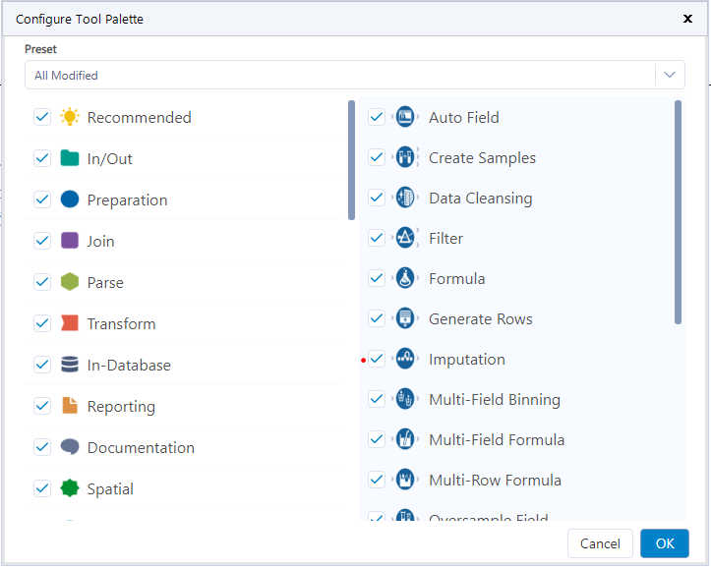
But if we wanted to keep them, we could impute values for the nulls.

Imputation Tool
The Imputation tool is part of the Preparation palette, but it may not be visible by default. You can find the Imputation tool by searching for it in the search bar on the top right, or you can make it viewable in your Preparation palette by clicking on the gear icon on the right side of the tool palette and checking the box next to the tool in the window that appears.
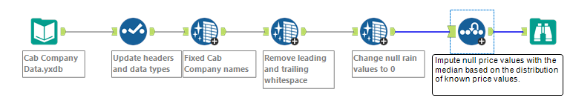
Drag an Imputation tool onto the Canvas and connect it to the most recent tool used.

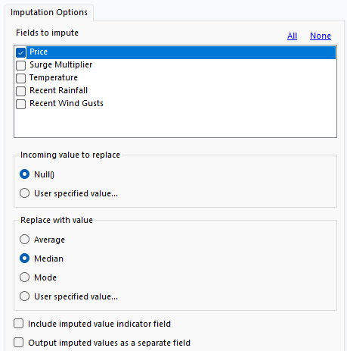
The Imputation tool is used to replace values in numeric columns. While it is most often used to replace null values, it could be used to replace any specified value.
In the Configuration window, select [Price] from Fields to impute, and choose Null() from Incoming value to replace.
When you choose to use imputation, the biggest decision is determining which value you are using to impute. Quite often an argument can be made for several options. You have to think through your data, make your decision, and be able to justify it.
Ask the students what value they would like to use and why. Have them make their choice and put their reasoning in a Comment tool near the Imputation tool. Run the workflow.
Based on the distribution of values, I am going to impute the median in this case.
Additionally, we could choose to use a more complex method for imputing values. For instance, we could look at the relationship between distance traveled and price, and use that to create a more accurate estimate of the missing price values. This requires a bit more thought, planning, and time to execute, but this can yield better results. For now, we will stick with relatively simple methods, but know that others exist.
There are other tools that we can use to impute numeric values in Designer. What separates the Imputation tool is its ability to calculate the mean, median, and mode of a column, and use those values for imputation without having to use additional tools.

Formula Tool
While we were able to address the null values in the [Price] field with the Imputation tool, we won’t be able to do the same in the [Cab Company] field because it is not numeric. Again, it is only nine values, we could remove them from the dataset without any real concern, but let’s keep them this time. Now, before we figure out how to do it, what do you think we should put for the 9 null values?
Have students share their thoughts on what should go in place of the null cab values.
Since the company Ride4Me is much more prevalent in the dataset, occurring 7x more frequently, we can replace the null values with that company name. While this may result in a few incorrectly identified records, they still represent a very small portion of the overall dataset.
There are a few ways to accomplish this task in Designer. Today we are going to do it with just the Formula tool.
Place a Formula tool on the Canvas after the Imputation Tool.
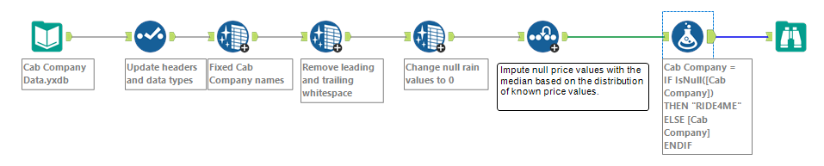
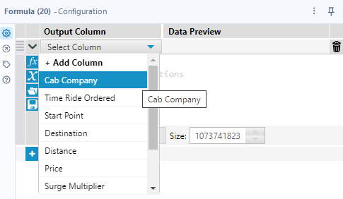
The Formula tool is one of the most diverse tools in Designer. We will spend more time with this tool later on, but for now, we are just going to replace the null values in the [Cab Company] column.
In the Configuration window, in the Select Column drop-down, choose [Cab Company].
This tells Designer that we are going to update values in an existing column. If we wanted to do this in a new column, we would choose Add Column and then type in the name for the new column.
We are going to write a conditional statement to accomplish our task. Remember, we don’t want to change all of the values in that column. We only want to replace the null values and leave all other values unchanged. A conditional statement will allow us to do that.
In the Configuration window, choose the function button, fx, from the panel on the left. Choose the Conditional grouping from the drop-down and select the first conditional statement.
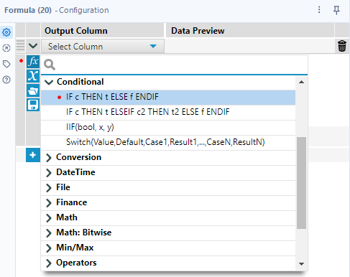
You don’t have to use this framework when typing in a conditional statement, you can just type the statement in. But for now, it might help you remember all of the pieces.
This is the logic that we need to communicate clearly with Designer.
If the value in the [Cab Company] column is null, then replace it with the name RIDE4ME. In all other records that aren’t null, leave the current value that is in the column. In proper syntax, that looks like this.
IF IsNull([Cab Company])
THEN "RIDE4ME"
ELSE [Cab Company]
ENDIF

IsNull() is a function that states whether a record is null or not. We have to put the column we want to search as the argument in that function. A list of available columns can be found in the X button on the left of the expression editor, or you can enter the left bracket,[, to get the list to appear.
Enter the IF statement in the expression editor.
The then statement says, if you met the prior condition, i.e. the value is null, then replace that value with the string RIDE4ME. All strings must be entered in quotations in expressions in Designer.
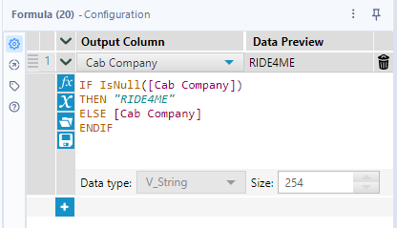
Enter the THEN statement in the expression editor.
The else statement is what to do with all the records that don’t meet our criteria, i.e. all the records that ARE NOT null. We want to leave those values unchanged. So, by specifying to use [Cab Company], it will use the values currently occupying the remaining cells.
Enter the ELSE statement in the expression editor.
All conditional expressions in Designer must end with ENDIF.
Notice that when the expression is entered correctly it is color-coded. This is an easy way to verify that you have used the correct syntax in your expression.
At this point we can run the workflow and our null records will be updated to our designated value.
Run the workflow.
Notice that the Formula tool automatically creates an annotation. We could update it if needed, but its current value is sufficient.
Now we no longer have any null values. This is a big step, but we can still improve our data.

Record ID
Many times, in datasets it is useful to have a simple way of identifying one record from another. In this case, it is possible, but it would require referencing multiple columns. (Many times, it's important to determine whether each row in a dataset is unique based on existing information. To do this, we need to ask: What combination of columns makes a record different from the rest?) For instance, if you quickly scan the [Time Ride Ordered] column you may notice that some rides were ordered on the same day, time and from the same company.
We would need to reference the time and the starting point to distinguish one from the other. (In this case, we can group by columns like Cab Company, Time Ride Ordered, and Start Point to check whether any combinations are repeated. If some groups contain more than one record, it means that combination alone isn't enough to uniquely identify each ride.)There may be instances where there are multiple rides at the same time from the same starting point, which would mean potentially referencing three cells to identify a particular record. Having a single simple identifier that delineates one record from another would make things much easier.
[You want to treat each observation with a distinct combination of Cab Company, Time Ride Ordered, and Start Point as a unique record].
We define a unique observation as one where the combination of Cab Company, Time Ride Ordered, and Start Point doesn't repeat in the dataset.
We can achieve that by using the Record ID tool. This is going to give each column a number as its identifier. This number will stick with the column even if it switches position and it’s an easy way of identifying and distinguishing a particular record from others.
Go to the Preparation Palette and drag a Record ID tool onto the Canvas after the Formula tool.
Side note: As we become comfortable with more tools in Designer, notice that the tools within a given category are listed in alphabetical order.
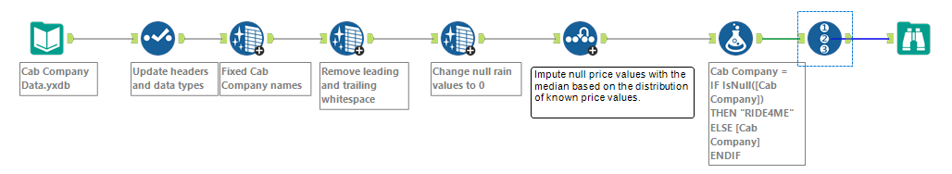
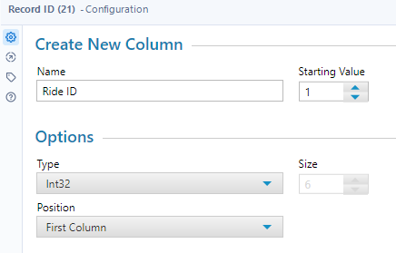
The configuration of the Record ID tool is very simple. We need to tell it the name of the new column that will contain the ID number, the value we want it to start with, the data type of that column, and where we want that column in the dataset.
Most of the time the only value you’ll change is the column name.
Change Name to Ride ID.
Run the workflow.

DateTime Tool
The last thing we are going to address is the [Time Ride Ordered] column. If you remember it is still listed as a string data type, which is not the best option for it since it contains date and time data. The problem is that the current format doesn’t meet the requirements for Alteryx to read it as a date time data type. However, there is a tool that can help with this, conveniently named the DateTime tool.
The DateTime tool is located in the Parse tool category, and it allows us to take strings with date time information and turn them into columns of date time data types, and vice versa.
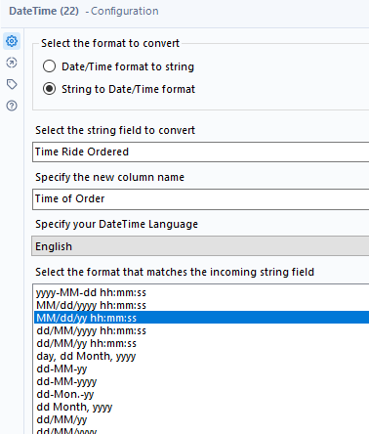
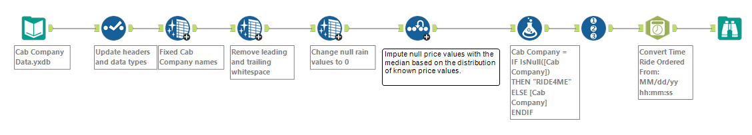
Go to the Parse palette and drag a DateTime tool onto the Canvas after the Record ID tool.
We have a string that we want to convert to a Date/Time format.
Choose String to Date/Time format.
Choose the [Time Ride Ordered] column within the Select the string field to convert drop-down.
Enter Time of Order in the section Specify the new column name.
Lastly, we need to tell the tool what the current format is. There is a list of options that you can select from if they meet the current format provided. If not, you can choose the Custom option at the bottom and enter your own. The tool will recognize the same basic abbreviations in the options provided, but you can also utilize date time specifiers if needed.
Select the third option from the list as it matches the current format of our string.
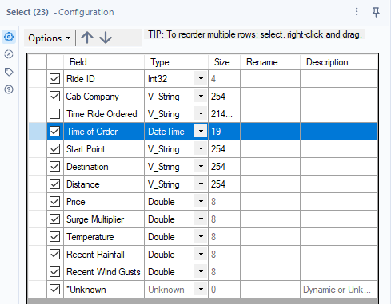
Run the workflow.
Notice that the DateTime tool automatically creates an annotation just like the Formula tool. It also creates a separate column for the newly created output column.
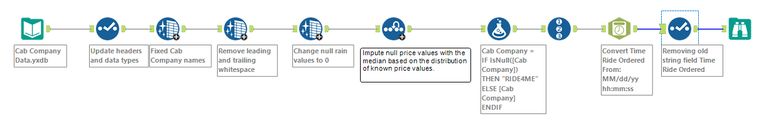
Ask the students to remove the old date string column and to move the newly created column in between the [Cab Company] and [Start Point] columns. This should only take a minute or two with a Select tool.

Feature Engineering
Our data is now cleaned and organized.
We already have a good amount of data to work with, but is there more we could do with this data? In particular, are there additional columns of data that we may want to create based on the data we already have that could help us find patterns in the pricing strategy? Using existing data to create more data is called Feature Engineering.
For instance, we have a column with the time the ride was ordered.
Ask students what elements of time might impact the pricing of a ride.
Sample Responses
- Time of day: You can talk about breaking the time of day into categories, and make a column with those time blocks (e.g. early morning, morning, afternoon, evening, and night) to see if there is a pattern between price and the different time blocks. Could make these time blocks with a conditional statement in the Formula tool.
- Rush Hour: Could see if prices were consistently higher during rush hour. A conditional statement in the Formula tool could be used to create a Boolean column identifying rides during rush hour.
- Holidays: Could check to see if any of the days are major holidays, and if that affects prices. If you know the dates, you could build a Boolean column that marks those days as holidays using a conditional statement, amongst other methods.
Depending on the amount of time left in class, feel free to build out some of these additional categories.
- Day of the week: This is the one we will build.
We can build the day of the week using the DateTime tool. While it can turn strings into date time data types, it can also take date time data types and produce string values.

DateTime tool
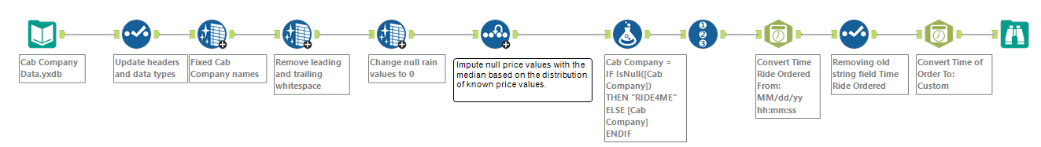
Attach a DateTime tool after the Select tool on the Canvas.

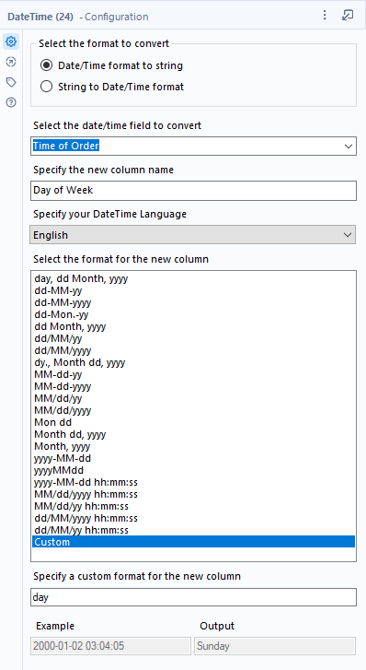
Choose Date/Time format to string.
Choose Time of Order as the field to convert.
Specify Day of Week as the new column name.
We aren’t looking for one of the provided formats, but we can enter our custom value.
Select Custom from the option and enter “day” (no quotes) as the new format at the bottom.
Notice the Output preview shows the day of the week.
Run the workflow.
Now we have an additional data column that specifies the day of the week. But, we can use this tool to create any date string we want. For example:
Change the custom value from day to dy. Mon. dd, yy
Run the workflow
As you can see, it keeps our specified punctuation and uses the abbreviations as well. Just be sure to use the examples or specifiers documentation as a guide for the correct syntax.
Revert to day and run the workflow.
For this problem, the original date time value may have been too specific, but once we break it into categories like day of the week, or even a time period within a day, that may provide more insights into patterns.
Use the Browse tool connected to the last DateTime tool to investigate what day of the week had the most cab rides.
Suppose we wanted to look further into rides that occurred on Saturdays and Sundays. To do this we can use a Filter tool.

Filter Tool
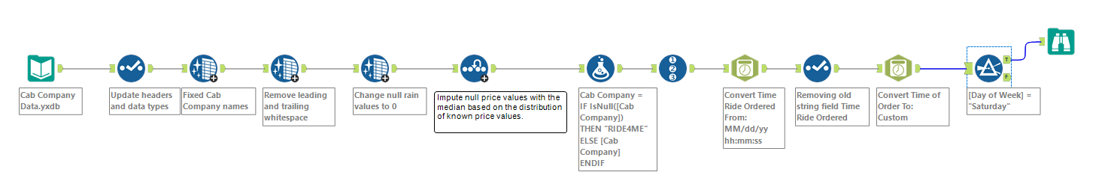
Locate the Filter tool in the Preparation palette and connect it to the last DateTime tool.
Notice that the tool has two output anchors. The Filter tool has two configuration options. The Basic filter uses drop-down menus to filter based on one column meeting one simple criteria. The options in those dropdowns will change based on the data type of the column chosen.
Explore [Start Point]-String type
[Time of Order]-Date type
[Price]- Numeric type
Notice as you change the conditions, the custom filter automatically updates with those changes too.
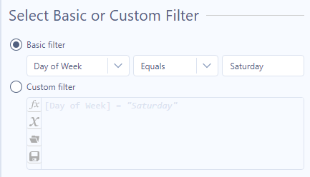
There is also a Custom filter option that allows us to apply more complex logic using an open expression editor.
We will start by configuring the tool using the Basic filter to limit our dataset to the day of the week being Saturday.
Have students walk you through building out the basic filter for just Saturday by using leading questions such as What column should we filter by? What condition should we apply? What word do we want to filter on? The configuration shown is the simplest method.
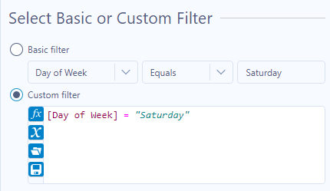
Notice as we configure the basic filter the custom filter automatically writes out the expression. Click the custom filter and let’s build onto the expression to include Sunday.
To adjust this expression to see all rides ordered on weekends, should we use an AND or an OR statement? OR, allow students to try their suggestions as we build out the expression.
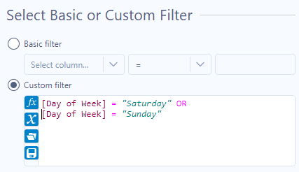
Add to the already populated formula
OR [Day of Week] = “Sunday”.
Looking at the two Browse tools, does it appear that the cab companies drive further on the weekend than on the weekdays? No, there is still a .02 mile difference between the averages.

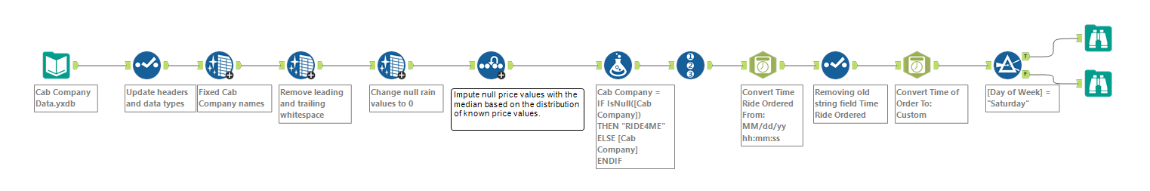
Attach a Browse tool to both output anchors and click run.
We now have all the rides that were ordered on a Saturday or Sunday in the T anchor and all other rides in the F anchor.

Alternative way to come up with Day of Week
Also, show alterative way to achieve this using formula.
Type Datetime in Search Bar to access DateTime functions Article.
https://help.alteryx.com/current/en/designer/functions/datetime-functions.html#idp377846
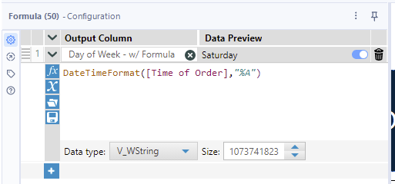
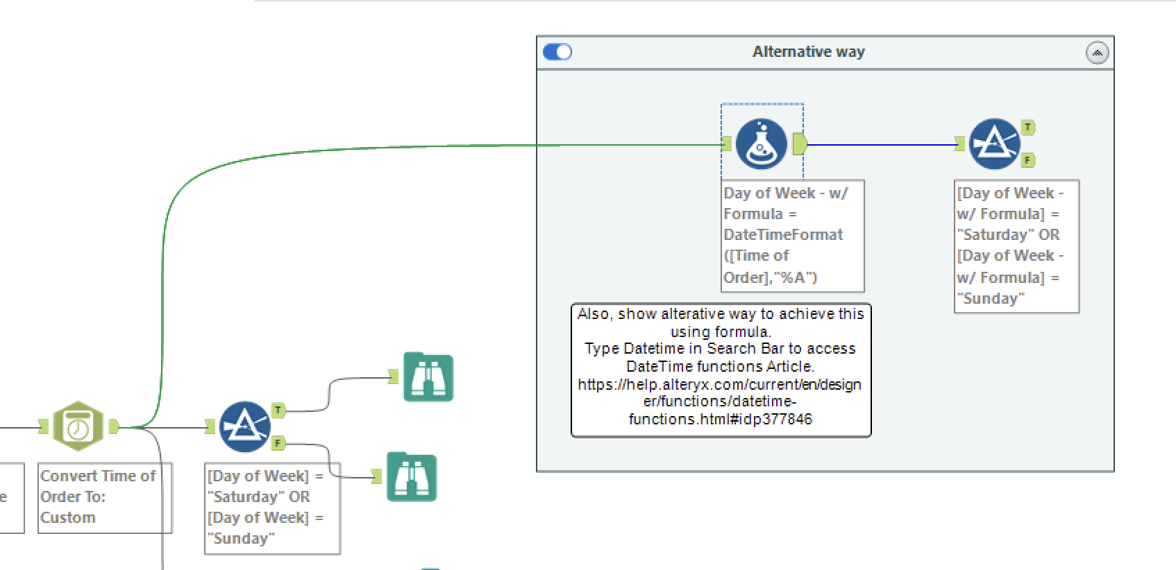

Toggling between the two Browse tools, does it appear that the distance traveled is further on Weekend? No, Weekend average and Weekday average distance travelled is not that different.

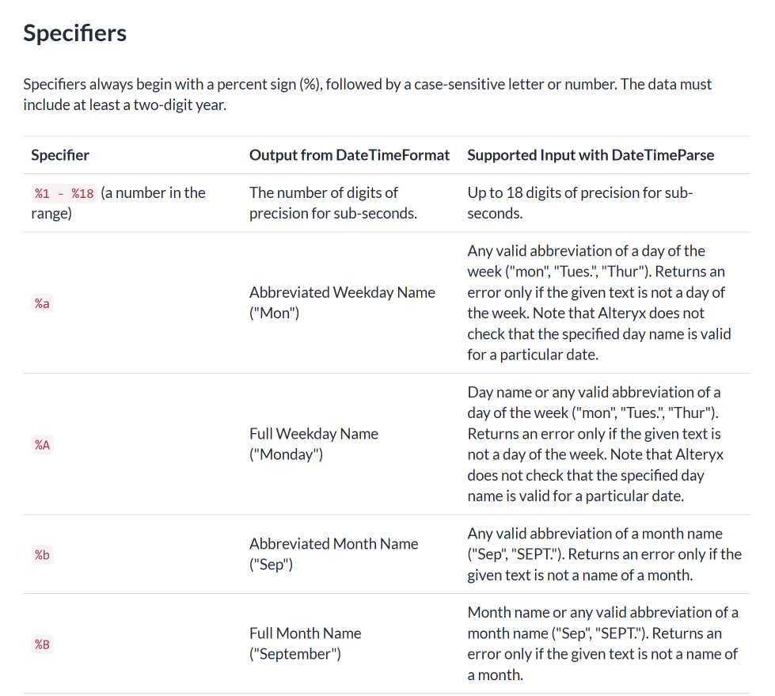
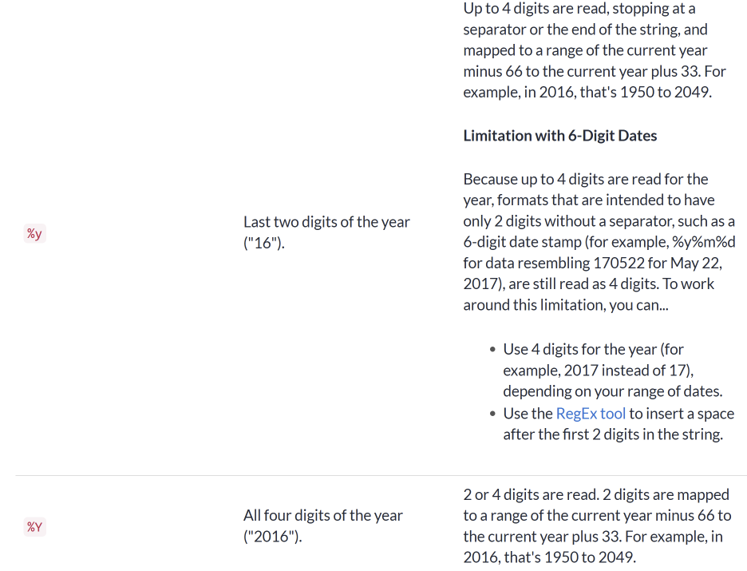

Class 3 – if continue with this dataset
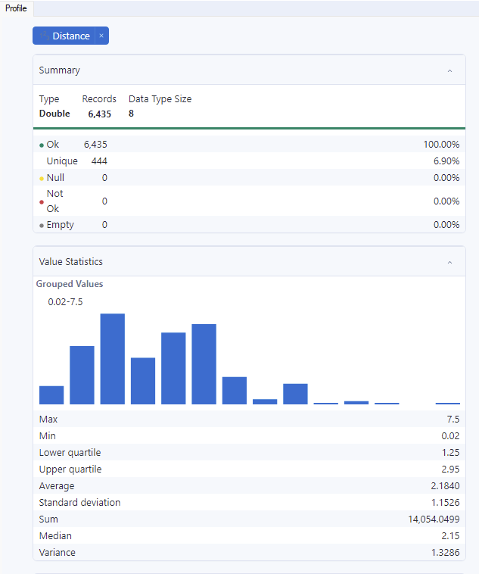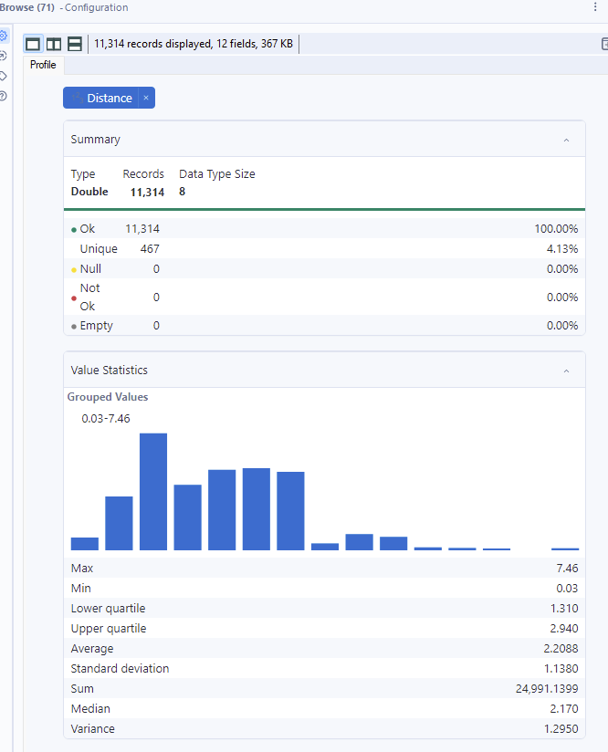

Continue looking into other filtering options.
Suppose we want to now investigate rides traveling to and from universities.
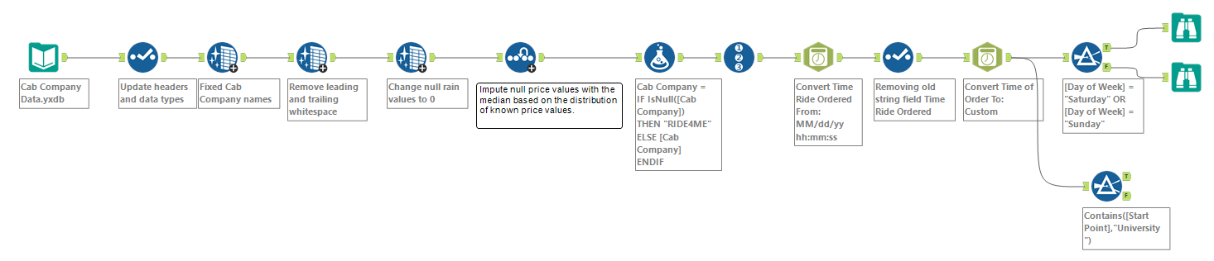
Bring another Filter tool onto the Canvas and place it below the first Filter tool. Set the filter to only include start points that are at universities.
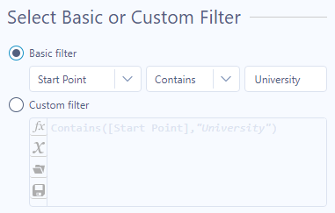
Again, start by configuring the tool using the Basic filter to limit our dataset to start points at universities. We want all starting points with the word University in the name.
Have students walk through configuring the basic filter.
Once the Basic filter is configured as shown, click the Custom filter radio button.

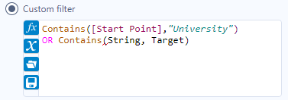
If we want all records of cab rides that had a start point or destination at a university, should this be an AND or OR conditional statement? OR, we want all records where University is in the starting point name or destination name.

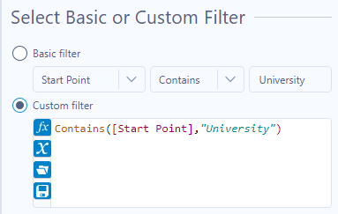
Add to the already populated expression, OR Contains, and select the contains formula.

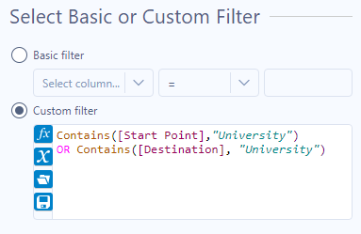
Replace String with [Destination] and Target with “University”.
Run the workflow.
Toggle between the two different anchors. Notice the records in the T anchor are the ones that met the filtering criteria. Those in the F anchor are the records that did not meet the criteria.
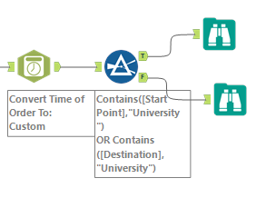
Add a Browse tool to both anchors of the Filter tool.

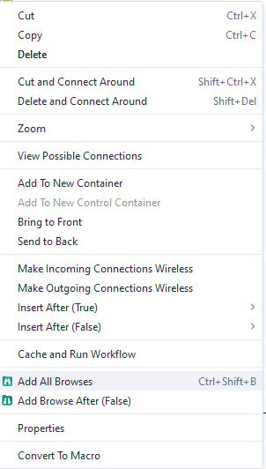

Note: You can right-click on the Filter tool and select Add All Browses to add them at the same time.
Run the workflow.
Allow students a few minutes to toggle between the two Browse tools and compare statistics of the cab rides that travel to and from universities and the rides that do not.
Allow students to share their findings.

Potential Findings (use Browse tools):

Distance:
Do cab rides to or from universities travel farther on average compared to rides that don’t involve a university? If so, by how much?
Cost:
Is there a difference in the average cost of cab rides involving universities versus those that do not? How much more do university-related rides typically cost?
Day of the Week Patterns:
On which days are cab rides to or from universities most common? How does that compare to the most common days for non-university rides?
Surge Pricing:
Is there a noticeable difference in the average surge multiplier between university-related rides and other rides?

Answers:
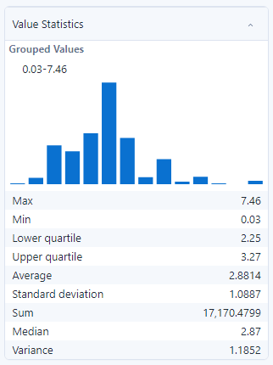
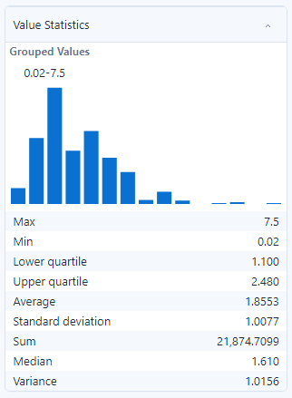
Cab rides to or from universities travel on average one mile farther than the rides that do not go to or from a university.

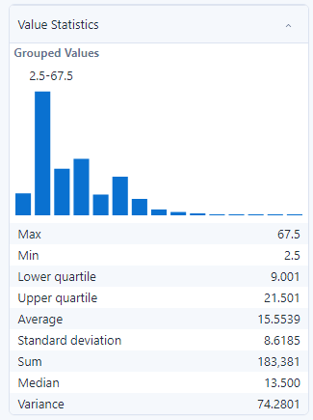
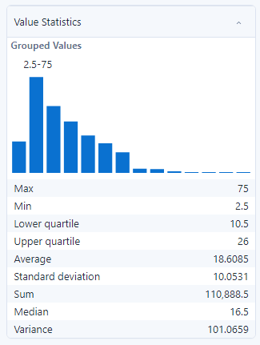
On average, rides to or from the university cost about $3 more than those not traveling to or from a university.

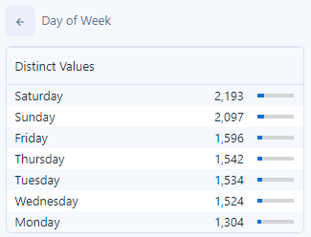
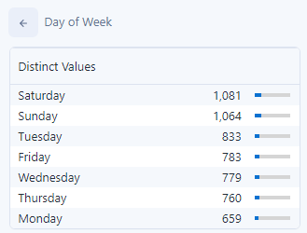
People tend to use cabs the most to travel to or from universities on Saturdays, Sundays, and Tuesdays. Whereas other rides occur most often on Saturdays, Sundays, and Fridays.

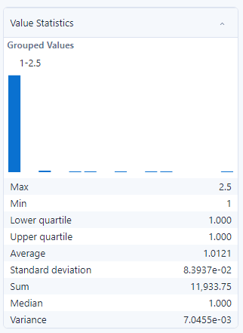
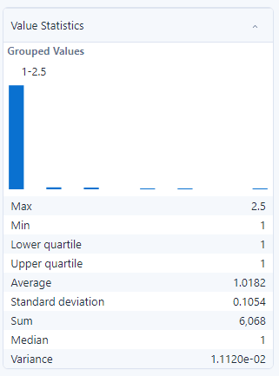
The average surge multiplier is about the same between the two.

Summarize Tool
Q1 : What is the most popular day of the week for trips to or from the university?
Q2 : Top 5 Most popular / busy hours
Q3 : Does Wind Gust affect the tendency to use cab?
Q5 : which starting point has the highest average price charged per distance (miles)?
Q5-A : which starting point has the highest average price charged per distance (miles) per each cab company?
Q6 : What is the most popular destination traveled to on Weekend?

Summarize Tool

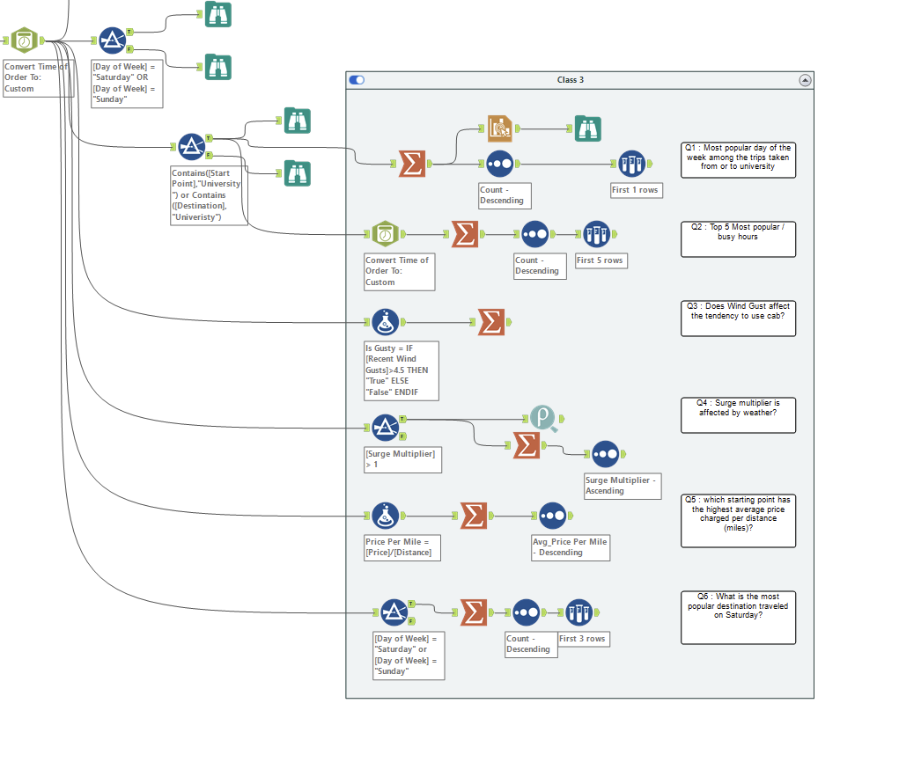

Question1 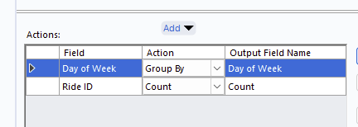

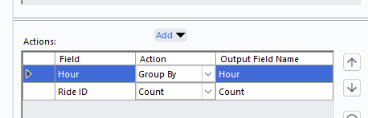
Question 2 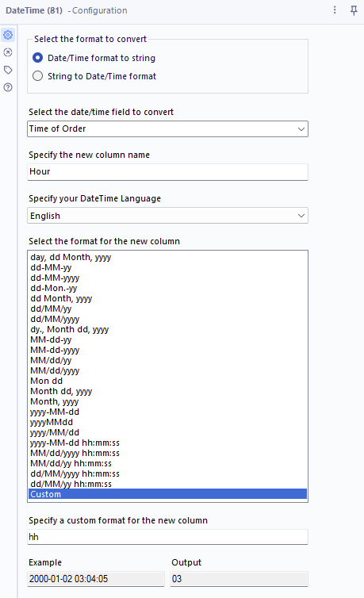

Question 3
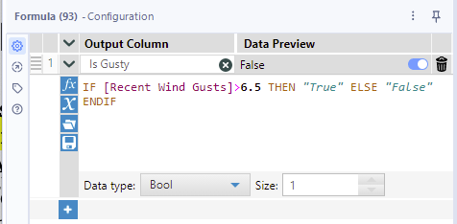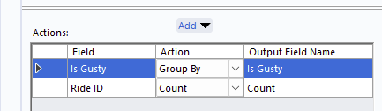
Question 4
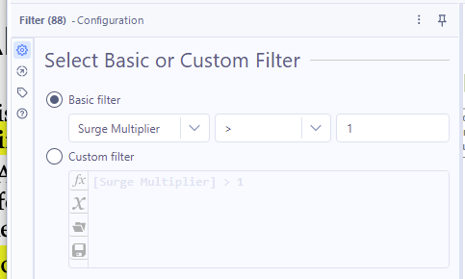
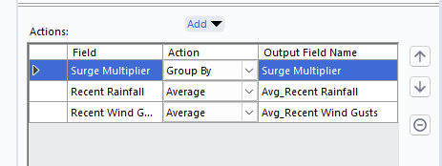

Question 5
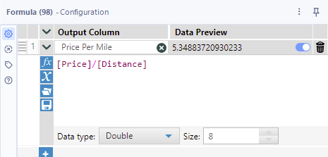
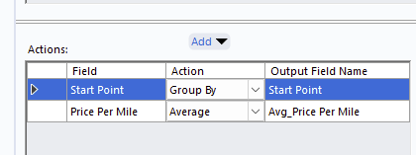

Question 6

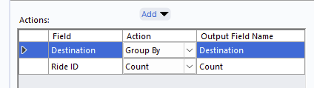

Last Task
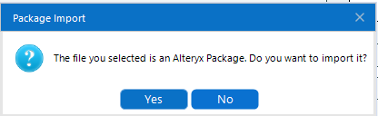
Tonight’s assignment is packaged as an Alteryx proprietary zip file. You will download it in the form of a .yxzp file. It will contain the workflow and the required datasets for the assignment. When you open it, you’ll have a pop-up about importing the package. Click Yes.

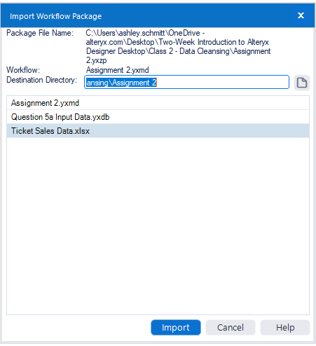
Then it will ask you where you want to import the files. Direct them to the same folder as today’s exercise using the Destination Directory. Then Click Import.
Click yes on the final pop-up that appears to open the workflow in Designer.
This series of actions will add the workflow and input data files to your folder. Any pre-configured Input Data tools will already have relative pathways set up.
There will be a series of questions in the workflow, some requiring written answers, some requiring tool configurations, and others requiring a small workflow build. Follow the instructions and answer all of the questions in the workflow.
You can show students the assignment and go over more details if necessary.
When you are finished, save the workflow in the same location, but update the title to include your name (ex: Assignment 2_John Doe.yxmd). Verify that you still have relative pathways on all inputs (and on all outputs for future assignments) and that the workflow executes properly.
When you submit your assignment, you can simply submit the .yxmd file. You do not have to package it with the data as I already have the data sets.

